Welcome! Mrs. Godke will be using the following places for distance learning:

**Assignments, Daily Work, and Class Interaction will be posted on Seesaw.**

<https://app.seesaw.me/>. This app may also be found through Clever. (sign in with Google: student’s school email and password)



**Other learning tools may be found through Clever.**

[www.Clever.com](http://www.clever.com) (Login with student’s school email and password)

*Google Classroom (**Art, Music, and P.E. Assignments**) 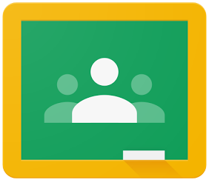

*Pearson Content - Easy Bridge (for **Science and Social Studies Assignments**) 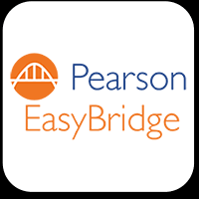

*Zearn (**Math Instruction**- Assigned Lessons - don’t work ahead on this.) 

*RazKids (Reading Comprehension) 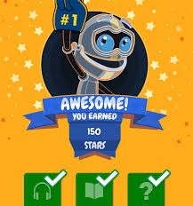

*IStation (Phonics Practice) 

*ST Math (Math Practice)